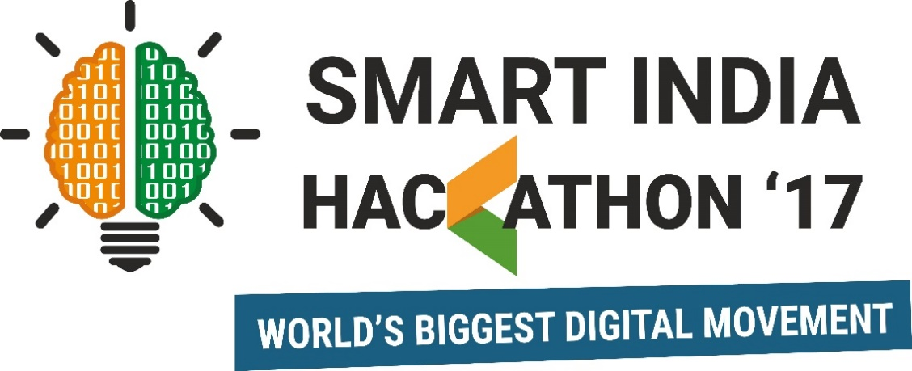

**SIH 2017**

**Deployment Report**

**Team Name and Title :** TER-X, RTBMS

**I4C ID : #**4727

**College Name :** CGC Technical

Campus, Jhanjeri,

Mohali

**Address :** SH12A, Jhanjeri,

Mohali

**Ministry :** Dept. of Atomic Energy

**Ministry Mentor’s Name and Contact Details :** Dr. Reetesh Chaurasia,

ritesh@dae.gov.in

**Team Leader Details**

|  |  |  |
| --- | --- | --- |
| **Name** | **Mobile Number** | **Email-id** |
| Komal Chauhan | 9034279856 | komalchauhan50@gmail.com |

**Team Members Details**

|  |  |  |
| --- | --- | --- |
| **Name** | **Mobile Number** | **Email-id** |
| Manmeet Kaur | 9646149851 | manmeetkaur0175@gmail.com |
| Jaspreet Singh Bhatti | 8146938196 | altairximate@gmail.com |
| Rajat Bishnoi | 7087555622 | rajatvishnoi28@gmail.com |
| Dipesh Saini | 9878242977 | dipeshsaini04@gmail.com |
| Shriya Wali | 8289024198 | shriyawali16@gmail.com |

**Mentors Details (if any):**

|  |  |  |
| --- | --- | --- |
| **Name** | **Mobile Number** | **Email-id** |
| Dr. Rajneesh Talwar | 8872048019 | principaljhanjeri@cgc.ac.in |

**Application Type:** Cross Platform (IoT + Web + Mobile App)

**Hardware Required:** Yes

**Can the Idea be Patented?** Yes

**Abstract:**

In today’s blue streak development in the field of Medical Science, we are detaching from the fact of the requirement of blood now and then. **“Blood is Life”**, as said by someone; if we know the units of blood type available at the nearest Hospital or Blood Bank in the time of urgency in just a moment from our smartphone instead of wandering here and there for it; might prove to be the most benevolent part in one’s help.

The way of cognizing the amount of blood available and needed with its blood type with many more features will be done through a mobile application; handy in our smartphones and a website for the hospitals and blood banks. The features of the mobile application include realizing the units of blood available in a particular hospital/blood bank from their updated databases; locating the nearest blood bank/hospital utilize\ng geo-tracking; live chat with the medical support available; stipulation of the blood type needed by the hospital/blood bank and some more additional features.

Keeping this view in mind, we tend to help all the near and dear ones with the facility of blood available just a call away. Also, all those who are willing to donate blood and help the society will get an instant vision of the blood banks/hospitals available nearby.

1. **Design Process**
   1. **System Architecture**
2. **Components and Portals:**

* **IoT:** Node MCU and RFID Tags/ Cards
* **Web:** Online Portal
* **Android:** Mobile App
* **Database:** Firebase

**ii. Workflow:**

A unit of IoT is installed in every hospital and each hospital is assigned a unique ID as per the administrator on the Web Dashboard. These IoT units have preformatted capability of scanning the RFID Cards, processing their data and then incrementing the count of the blood type and the blood component if any same unit is found in it.

Thereafter, the information stored is available on the Admin Dashboard on the Web Portal which can be easily accessed by the

administrator by logging in with their User ID and Password credentials.

The Android App is for the end users where they can check for the availability of a specific blood type in their city very easily.

* 1. **Technologies Used**

**IoT:** C, C++, Embedded C, Python

**Web:** HTML5, CSS3, JavaScript, Ajax, jQuery, Google Material Design

**Android:** Java, XML, Google Maps API

**Database:** Firebase (NoSQL database by Google)

* 1. **Use Cases**

1. **For the Hospitals:**

Institutions will be first required to register themselves through the online portal. Once the hospital has been registered by the admin, then they will be provided with login credentials that will be used to update the blood status in their reserve. They will be able to update the units of blood and its category in the application’s database through the online portal and even post their requirements for blood on the website/mobile application. Facility for notifications regarding the upcoming events like blood donation camps, awareness seminars, etc. is declared in the form of notifications for the nearby donors.

1. **For the Users:**

Users will be required to first register themselves through mobile app. Thereafter they will be able to track the nearest Blood Bank and Hospital with the units of blood available with them as per the request made by them. Users can track the nearest pharmacy (via geo-tracking). Post a query for any medical assistance. The Users will also be notified about the upcoming events of the nearest Hospitals and Blood Banks. Also, they will be kept up-to-date with the latest advancements in health care by the Science menu and some of the do’s and don’ts to be followed before, while and after donating blood.

1. **For the Administrators:**

The administrators are the State or Central Health Authorities and they can keep an eye on the hospitals as per their state and city bifurcation. Also, they can add/delete a hospital/ blood bank to the portal. They can monitor the various activities being conducted by the hospitals and their reserves for the amount of blood units available.

* 1. **Source Code organization details**

*The basic purpose of this section is to understand, how code repository is organized. Explain folder structure and files used in your project. You may like to add details of few important files and their utilization (e.g. Configuration ... ....)*

1. **Features Implemented**

**IoT:**

* The IoT unit of the product is responsible for collecting the information of the blood unit available and being transferred to the user by the regular scanning of RFID cards for the entry and withdrawal of different blood units within a hospital/ blood bank.
* Also, it checks for the no. of blood units present for a particular blood type in the hospital and increments the count as and when a similar blood type is added/deleted to/from the hospital’s reserve.

**Web:**

The web portal is the handle for administrators and hospitals for managing the information being transmitted over the network of individuals on the app and the hospitals/ blood banks connected to our system.

1. **Admin View:**

Admin view refers to either the State Health Authorities or the Central Health Authorities. The administrator is capable of doing various tasks:

* Adding a new hospital/ blood bank to our network.
* Viewing the reserve of all the hospitals/ blood banks as per their city and state.
* Adding the new advancements in healthcare to our portal.
* Keeping a record of all the events conducted by various hospitals in their city/state as per the admin role.

1. **Hospital View:**

The hospitals are the entry level users in this online portal. The tasks that can be performed by a hospital are:

* Keep a check of their reserve as per the different blood types.
* Add new event notifications for the nearby individuals and update/delete the previous added events.
* Add new updates about their facilities or advancements made by them or by the healthcare dept.
* Edit their profile.

**Mobile App:**

The mobile application as per the problem statement has been developed for the individuals and is currently available for Android users. It has many features:

* Search for a particular blood type in their city, here the user can easily search for the required blood type in their city and they will be routed to the nearest hospital/ blood bank having the particular blood type through Geo-tracking.
* Be aware of the do’s and don’ts before, while and after donating blood.
* Be up-to-date with the latest advancements or facilities added to the hospital/ blood bank or the healthcare sector.
* Track the nearest pharmacy as per their location.
* Give feedback for any feature not found worthy or for any improvements/ appraisals.
* Edit their profile.

1. **Deployment Process**

The deployment is divided into four parts:

1. **IoT:**

For deploying the IoT component, we need a Node MCU and a set of RFID Tags/ Cards and an Internet connection through WiFi. The changes in the code (if any) or for viewing the code we can make it by using the Arduino IDE. The Node MCU is configured to the Internet by passing the SSID of the WiFi Network and the password, the database URL in the configuration file. Thereafter, it is tested for the connection with the WiFi by sending a test packet to the database. When the IoT unit turns on, the LED glows red, then, if the internet connection is successfully established, the yellow LED glows

and when the information packet is successfully transmitted, the green LED glows up and then switches back to yellow after blinking once. In between of these operations, no other operation can be performed.

1. **Web**

Deploying the web portal requires a web server, domain and a hosting service from any popular hosting provider. Also, we need to set up the connection with the Firebase Authentication (Email and Password) & Database by preparing the configuration file. Setting up the FTP Client on our local computer, we can easily upload the website content to our domain by first sending a test packet and then the contents of the website. Thereafter, whenever we have some changes, the files will be uploaded to the web server. For running the website locally, we need to install XAMPP on our computer and for viewing the code files or for making any changes to it, we need a text editor, I used Microsoft VS Code.

1. **Android**

For the app, we need a Google Play Store account for the Android users. The android app must be connected to the Firebase Authentication & Database by including various implementations in the Gradle file of the app and project level. Also, we need to connect the Android Project to the Google Maps API through the Google Developer’s Console by registering our Android Project details after signing in with our Gmail account on the console. Thereafter, we’ll obtain an API key which we have to insert in our code for the successful implementation of the Geo-tracking feature in the App. For viewing the code and building a signed APK of the App or for making any kind of changes in the code, we require Android Studio IDE with the latest gradle build and Android updates.

1. **Database**

The database has been developed on the Firebase database, a No SQL database by Google. We can create a new database by just going to the URL <https://console.firebase.google.com> and signing in with your Gmail account, thereafter you need to create a new project from your dashboard by providing the Project Details and Country. You’ll be redirected to the project dashboard where you can add the database configurations to your Android/iOS, IoT and Web App. Henceforth, you need to setup the

Authentication mode for the Android app to Gmail and Email-Password Authentication mode for the Web app. Once set, now you need to navigate to the left column Develop->Database and here you need to set up the database rules and its’ structure as depicted in the image below.

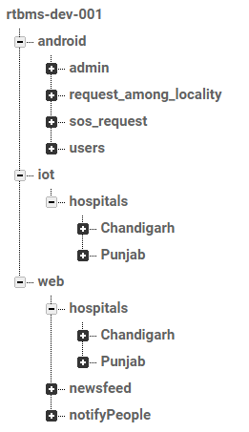

1. **Future Scope:**